Skill 8, 9 & 10:

8. To Detect Variable References, Expand Values, Handle Undefined Variables, Update Tokens, Support Nested Variables, Test Expansion Logic.
To Identify Built-ins, Create Dispatch Table, Execute In-Process Commands, Handle Invalid Commands, Maintain State, Test Dispatch Logic.
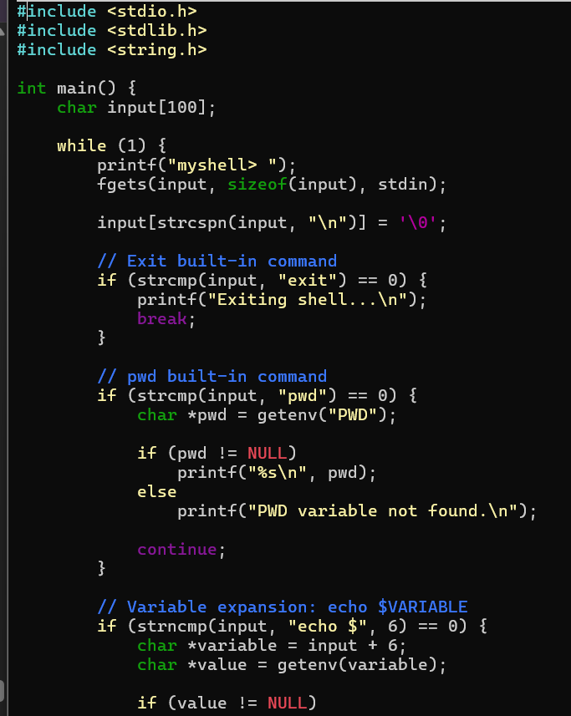
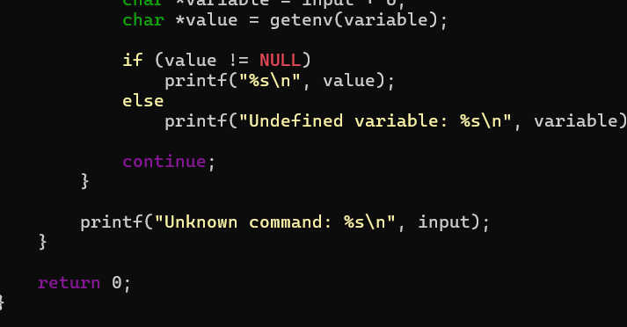
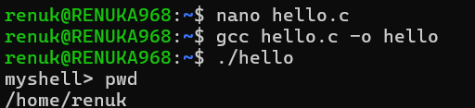

9. To Change Directories, Validate Paths, Update Working Directory, Handle Errors, Maintain Previous Directory, Test Navigation.
To Identify Built-ins, Create Dispatch Table, Execute In-Process Commands, Handle Invalid Commands, Maintain State, Test Dispatch Logic.
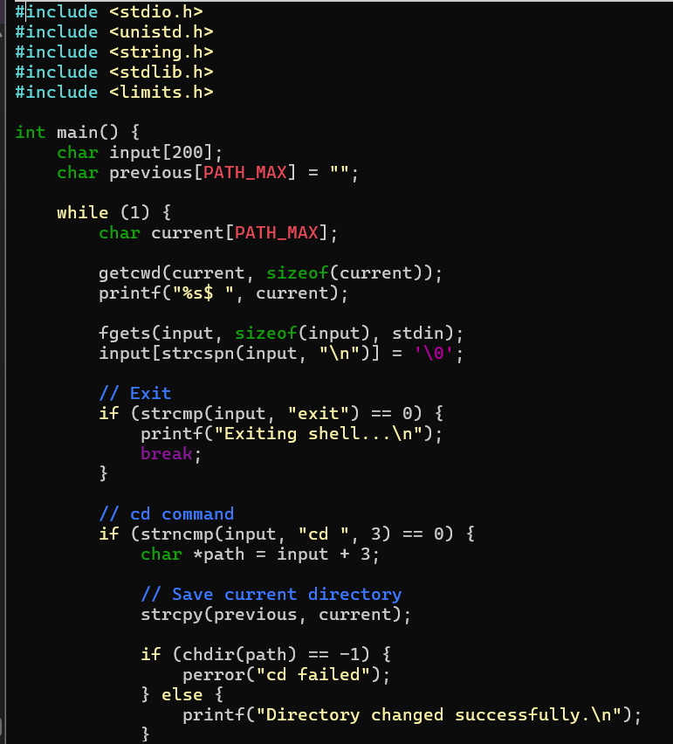
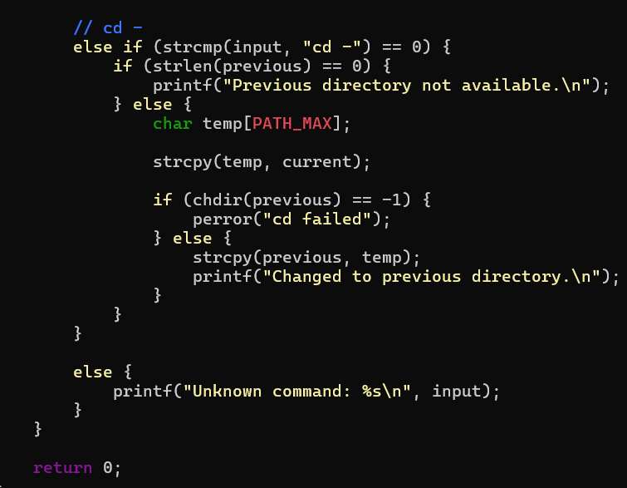
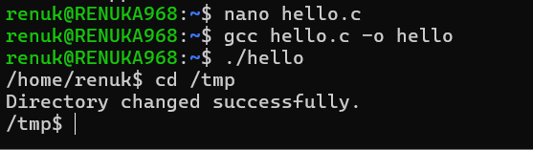

10. To Retrieve Current Directory, Display Path, Process Exit Requests, Cleanup Resources, Save State, Verify Correct Behavior.
To Parse Export Syntax, Update Environment Variables, Validate Names, Handle Existing Variables, Export to Child Processes, Test Functionality.
